Experiment – 7: Data Visualization Using Tableau (
AIM:
To visualize and analyze IPL player performance and team statistics using Tableau by creating interactive dashboards consisting of various charts and graphs.
Dataset Used:
IPL Dataset (Columns may include: Player, Country, Team, Age, Captaincy Experience, Playing Role, Matches, Innings, Runs, Batting Average, Strike Rate, Fours, Sixes, Wickets, Bowling Average, Economy Rate, and Sold Price, etc.)
PROCEDURE:

1) Importing Dataset into Tableau
Steps:
- Open Tableau Desktop or Tableau Public.
- On the Start Page, under Connect, click on the data source type:
→ Microsoft Excel / Text/CSV (depending on your file format).
- Browse and select your IPL dataset file (IPL dataset final.csv).
- Click Open, then go to Sheet 1 to begin visualization.

🔍 2) Exploring the Data
• Check that Tableau correctly identifies field types:
- Dimensions (blue): Player, Country, Team, Age, Playing Role, Captaincy Experience.
- Measures (green): Matches, Innings, Runs, Average, Strike Rate, Fours, Sixes, Wickets, Economy Rate, Sold Price, etc.
• Rename or change data types if necessary (e.g., convert numeric fields like Runs or Age to Number (Whole) type).

Step 1 : Importing Data as CSV files
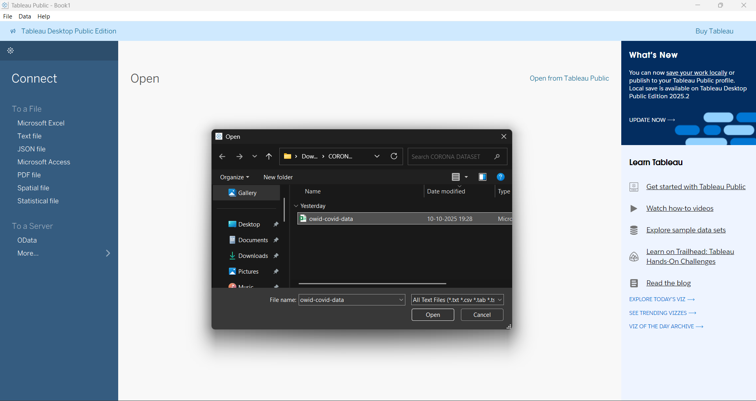

Step 2: First Page after uploading, now click on sheet 1 to open the visualization page

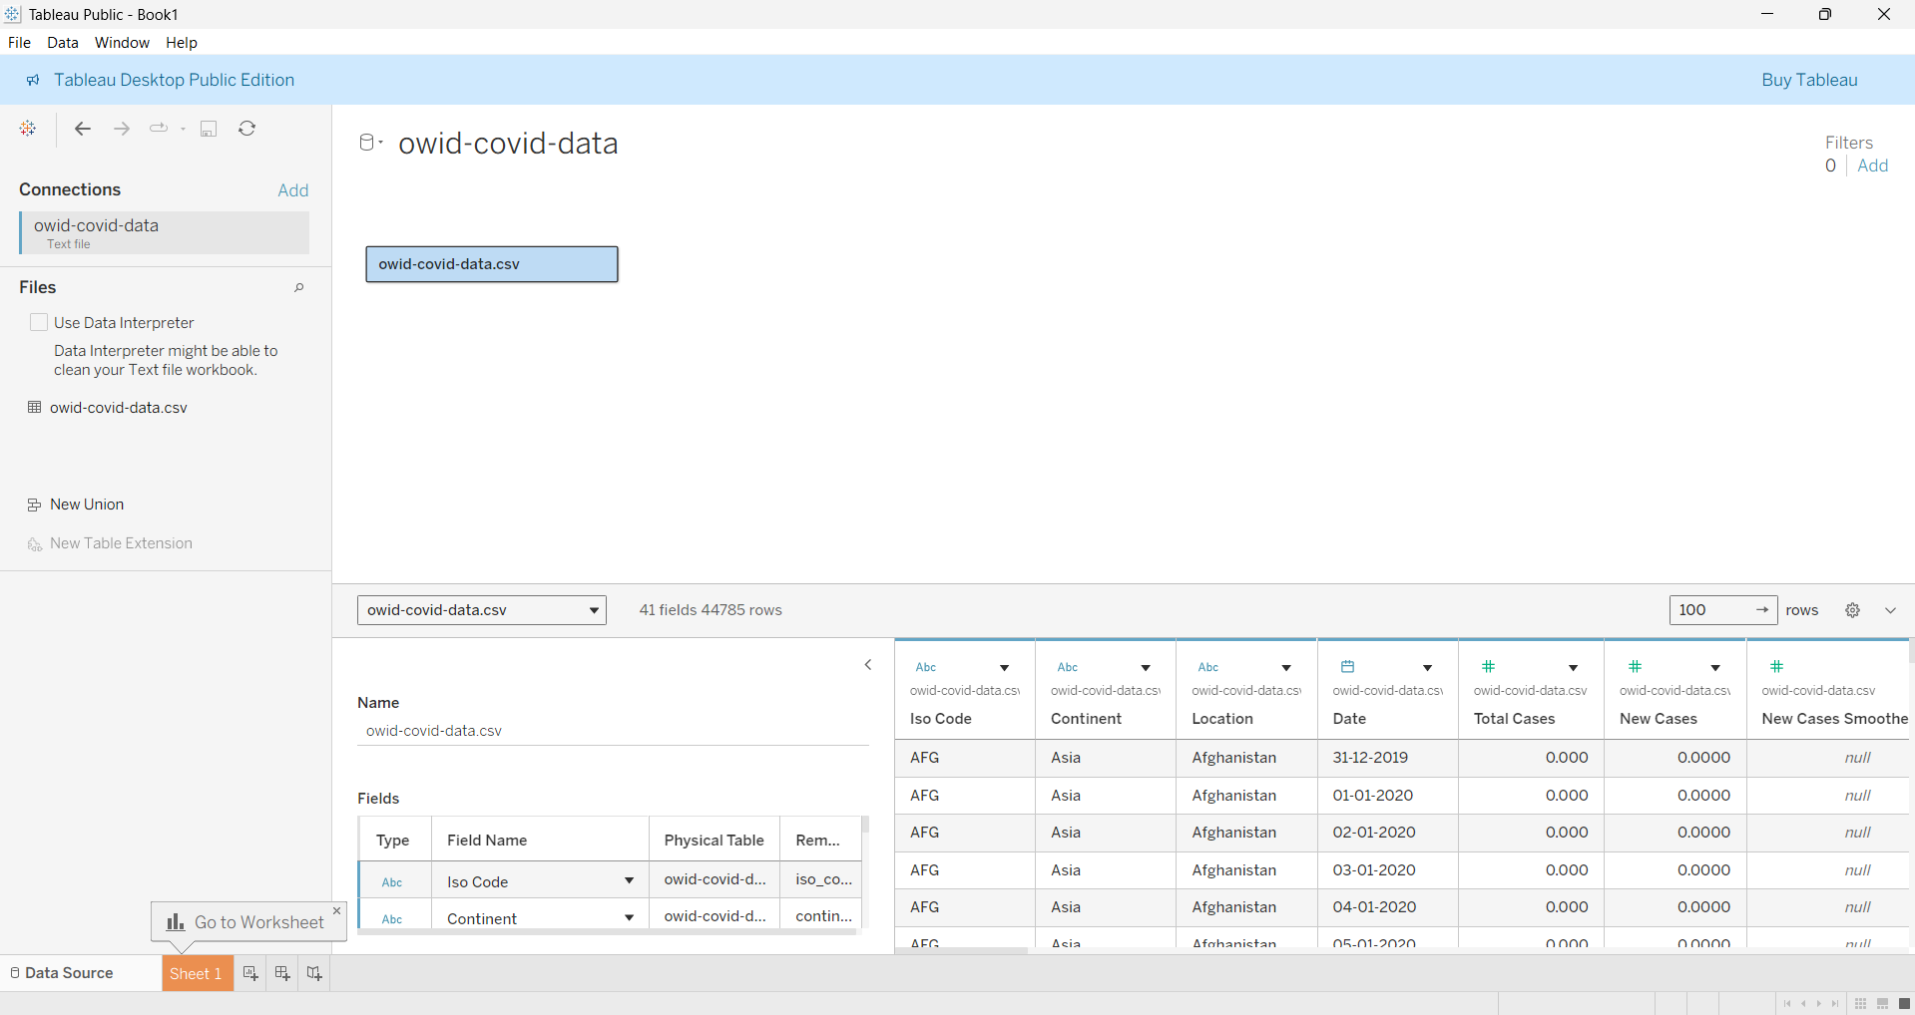

Step 3: This is the Visualization Page
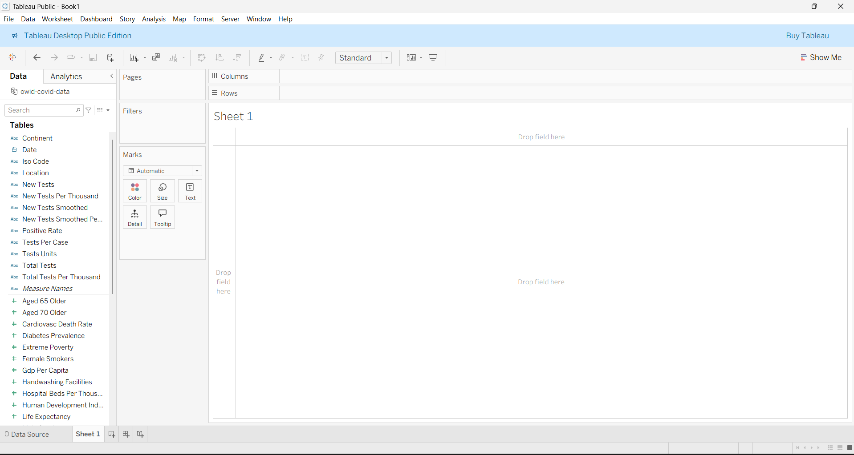

Types Of Graphs :

1 . Bar Graph(Side-by-Side Graph) :
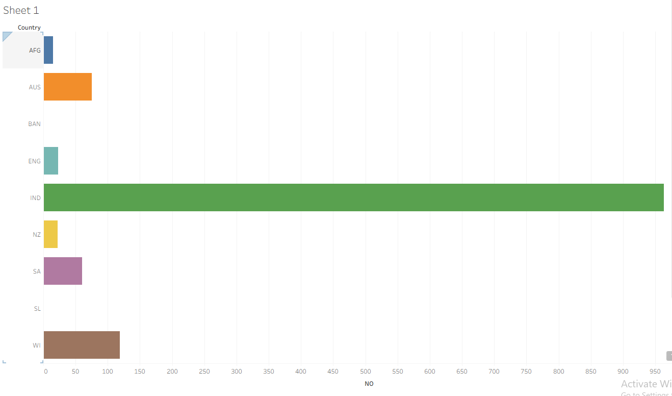

2.HORIZONTAL BAR :
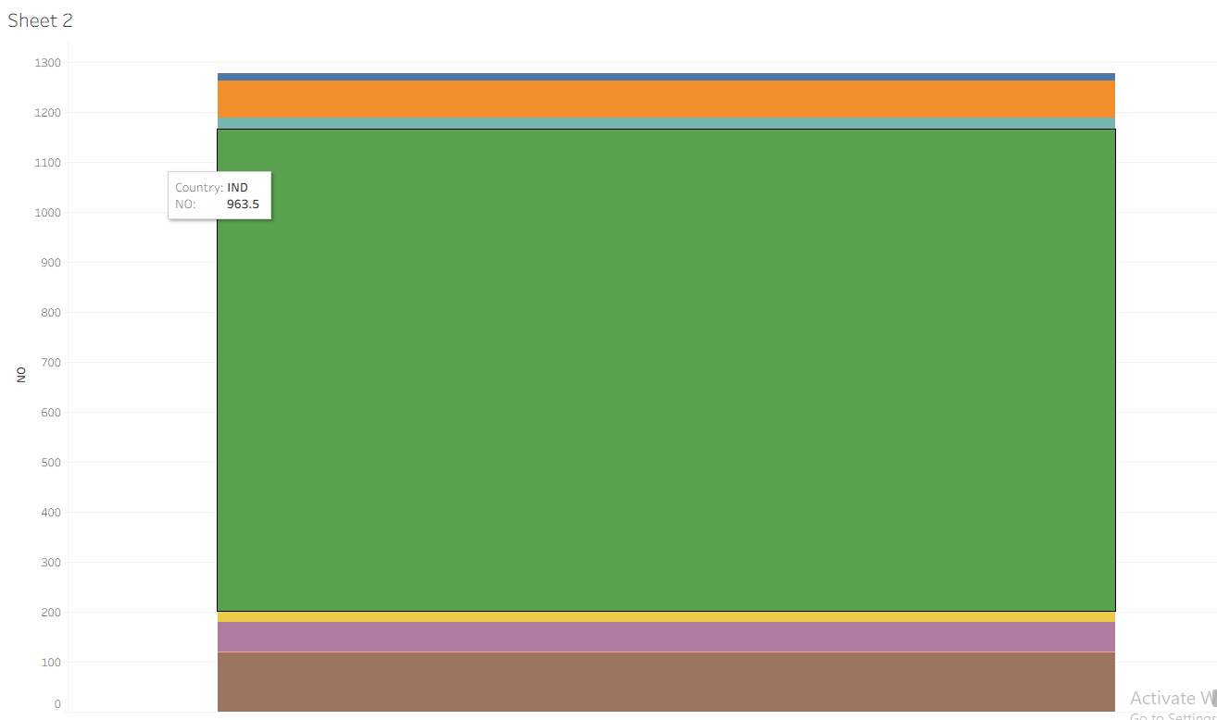

3. SCATTER PLOT :
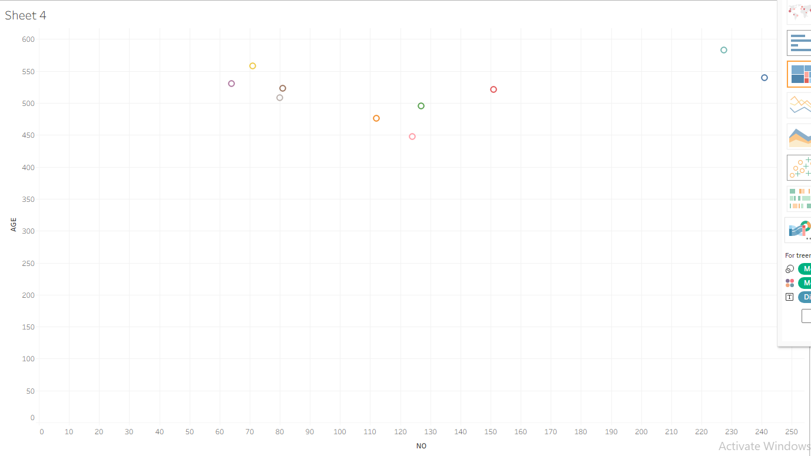

4.BOX PLOT :
